Winging of the scapula
Exercises aim to improve postural malaligment.
Barbell incline shoulder raise
This targets the Serratus Anterior muscle which passes between the thoracic wall and the shoulder blade and attaches to the middle side of the shoulder blade (medial side of scapula). By strengthening this muscle, it will help stabilize the shoulder blade (scapula) against the thoracic wall, bringing them back to normal position.
Position- Client lies on an incline bench. Have hand shoulder width apart with arms and elbows extended overhead. Take the barbell of the rack, grasping it with palm facing away from the client (pronated).
Raise shoulders us as far as possible and bring back to starting position. Perform 3 set, 10 repetitions. When exercise become too easy increase to 5 sets and 12 repetitions and/or increase weight.
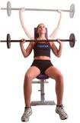
Cable Seated Row
Aims to strengthen general back
Sit on bench, place feet on foot rests and slightly bend them (flex 15 degrease), flex spine to reach for and grasp cable attachment without moving legs.
Pull cables to waist while straightening lower back. Pull shoulders back have chest out while arching the back. Return until arms are extended, shoulders are stretched forward, and lower back is flexed forward. Perform 3 set, 10 repetitions. When exercise become too easy increase to 5 sets and 12 repetitions and/or increase weight.
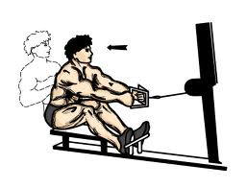
Doorway modified stretch press
Stretch aims to lengthen out the muscles that perform the opposite movement (synergist muscles). Muscles suspected to be shortened, or in a shortened position, pectoralis minor and major.
Stand parallel to door way with shoulder raised at shoulder level (adducted at 90 decreases) and elbow flexed at 90 degrees and wrist facing the wall (pronated). Push into wall for 30 seconds and switch arms.
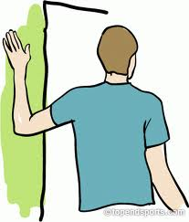
Dumbbell rows
Aim to isolate Rhomboids and Latissimus Dorsi, which are both muscle involved in stabilizing scapula.
Starting position- client is bent over on a bench with one leg at 90 degrease and one arm fully extended. Other leg is in the ground fully extended and arm is fully extended, holding a dumbbell, wrist is in neutral. Making sure the back is flat in order to prevent spinal injuries.
Pull dumbbell up towards body extending the shoulder as far as possible, making sure that the arm is stabilized and close to the thorax. Perform 3 set, 10 repetitions. When exercise become too easy increase to 5 sets and 12 repetitions and/or increase weight.
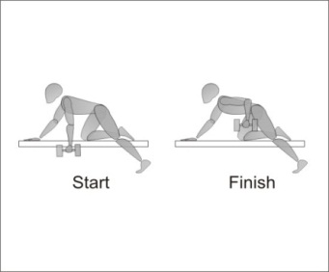
Reference
ExRx.net (n.d). Common Postural Deficiencies. Retrieved from
http://www.exrx.net/Kinesiology/Posture.html

