Clinical follow up
Corrective exercises and stretches for Hyperlordosis
Dessy Botzeva
MSTH 210
On-campus internship
December 01, 2011

Hyperlordosis background
People with this postural malaligment using have the following postural discrepancies: anterior pelvic tilt, hyper extended back due to shortened erector spinae and Quadratus Lumborum muscles, slight hip flexion due to shortened or hypertonic r hip flexor muscles such as, rectus femoris, and Sartorius muscles. Glute and abdominal muscles are generally weak or lengthened.
Excersizes and stretches for Lordotic Posture Malaligment
Kneeling hip flexor stretch
Aimes to stretch out Iliopsoas
Client has both knees in 90 degrease. Kneeling, client bring one hip up into 90 degrees flexion and pushes body forward into the same leg, stretching out the hip flexors in the opposite hip muscles. Keep back straight. Hold stretch for 30 seconds and switch legs.
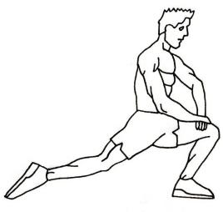
Seated Bent-over Lower Back stretch
Aims to stretch Erector Spinae Muscles
Client is seated on a chair with back straight and legs more than shoulder width apart. Bending forward and flexiong the spine, with shoulders in between legs, the client reaches for the back legs of the chair. Hold stretch 30 seconds.
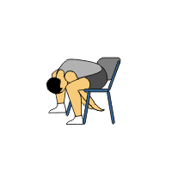

Crunches
Aims to strengthen Rectus Abdominis and Obliques.
Laying on the mat with knees at 90 degrees, bring trunk toward the legs, keeping the back straight and head is facing the ceiling. Perform 3 set and 10 reps, increase to 5 reps and 12 sets when exercise becomes too easy.
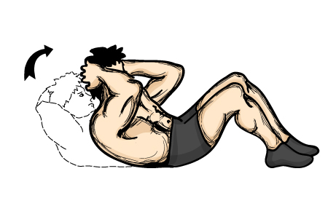
Lever Seated Leg Curl
Aim to strengthen Hamstrings
Client sits on apparatus with back against padded back support. Place back of lower leg on top of padded lever. Secure lap pad against thigh just above knees. Grasp handles on lap support.
Pull lever to back of thighs by flexing knees. Return lever until knees are straight. Repeat. Perform 3 set and 10 reps, increase to 5 reps and 12 sets when exercise becomes too easy.

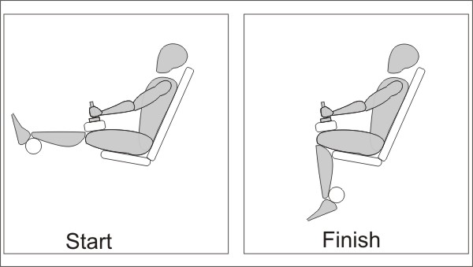

Seated legs press

Aim to strengthen Gludius Maximus.

Client sits on machine with back supported and knees and hips flexed, resting the feet on the machine pad. Straightening knees until they are fully extended and hips are at 90 degrease.

